Ayush Thapa

Date of Submission: 27/08/2024

Assignment 1 Data Visualization

Contents

Scenario 1

First Task 2

Policies and Procedures 2

Second Task 3

Excel: GDP 3

Third Task 19

Tableau 19

A reflective 34

Reference 35

## 

## Scenario

The purpose of this report is to analyse the provided ‘The Wealth of Nations’ data of different corners of the businesses, create visualisations and transform the information into meaningful insights for better decision making and business outcomes.

# 

# First Task

## Policies and Procedures

In data analysis, there are several important policies and procedures that need to be followed to get the best results possible. A few of them are:

1. Information/ Data should come from reliable sources: This makes the result/ conclusion genuine and accurate. Or else, we get a fake news kind of scenario.
2. Always check the supplied data: Check the data or table for any mistakes and missing values. If necessary, transform the raw data at hand by using appropriate features such as ‘Power Query’ in MS Excel, to fix minor errors like removing duplicate values, and filling in the missing values, spelling errors, capitalisation, etc. This part is called ‘data cleaning.’
3. Data security: Sensitive data need to be protected by following the company’s proper guidelines and procedures (for e.g. using protected marking schemes: Unrestricted, Restricted, Highly Restricted, etc) to prevent security breaches. **(Twilio Inc. 2024)**
4. Usage: There are times when customer’s approval is needed for data sharing with other third parties. Without the customer’s consent - selling, purchasing or misusing their information and details is technically considered a cybercrime.

So, a data analyst must be aware of such rules and regulations for high-quality data analysis and reporting.

# Second Task

## Excel: GDP

1.

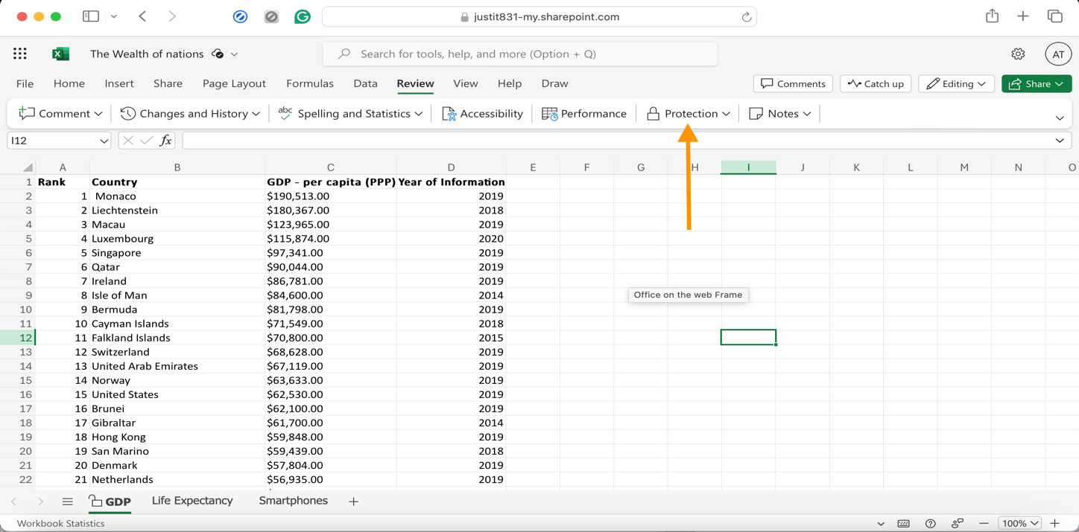

The worksheet was protected by selecting the ‘Protection’ option from the ‘Review’ tab as shown in the screenshot above. (The password is 123).

2.

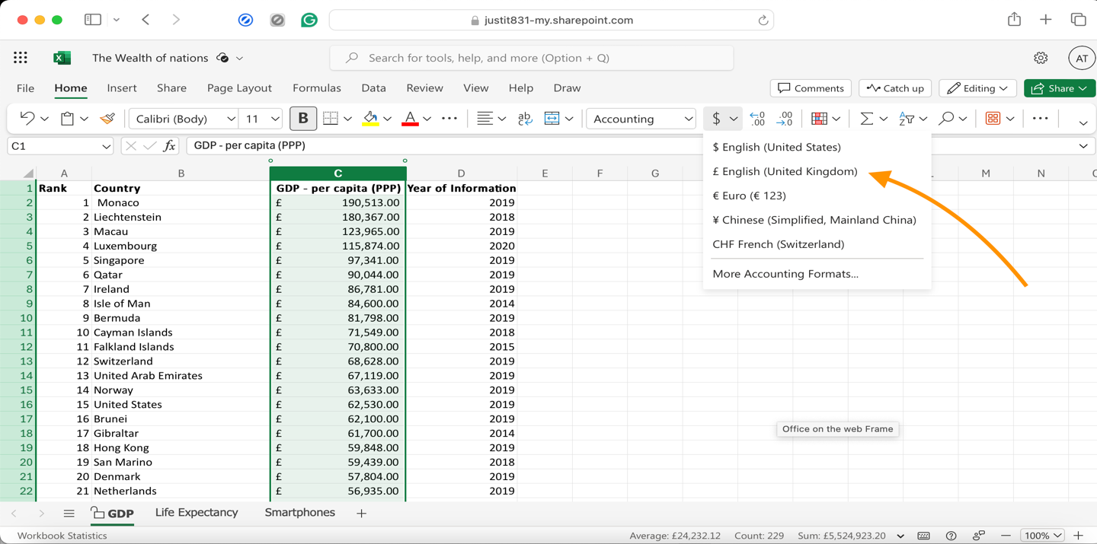

Highlighting the column C, the data was changed to British Pound symbol (£) by selecting the currency option located in the home tab as shown above.

3.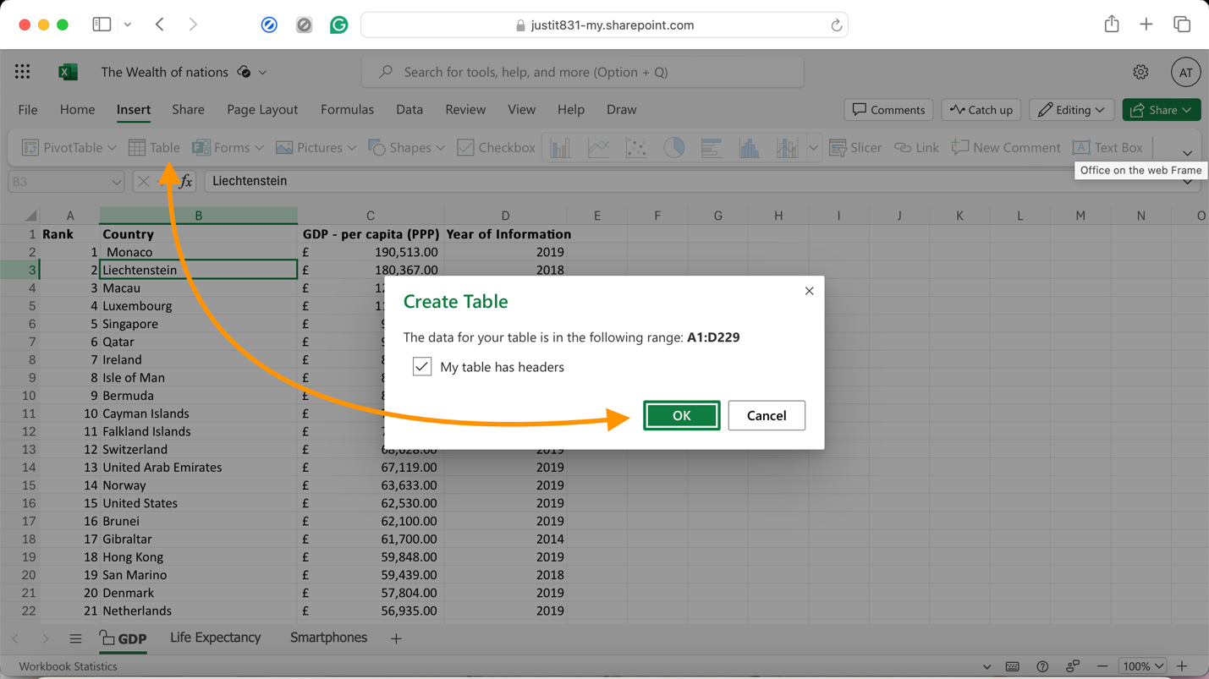From the ‘Insert’ tab, a table was created by clicking on the ‘Table’ option. This converted the supplied data in the GDP sheet into a table.

4.

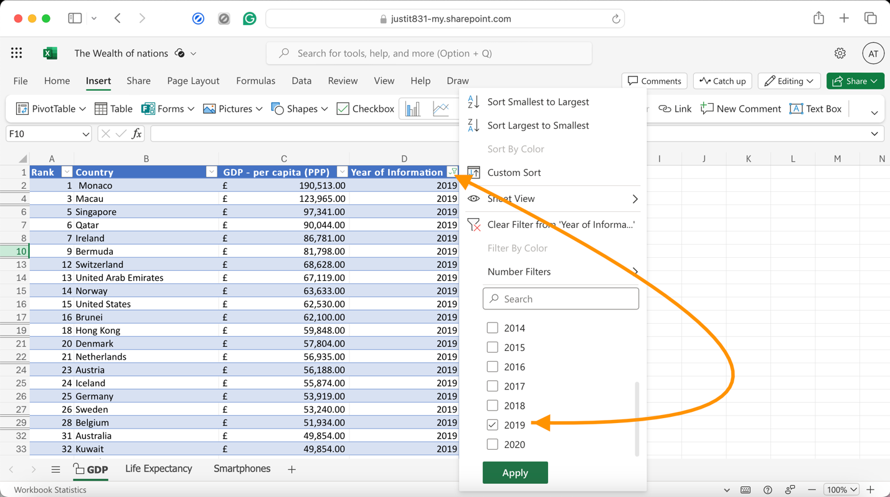

The table created above in the step no. 3 automatically creates a ‘filter’ dropdown option in the table header as displayed in the above picture. From the ‘Year of Information’ column, only ‘2019’ year was selected to display the information.

5.

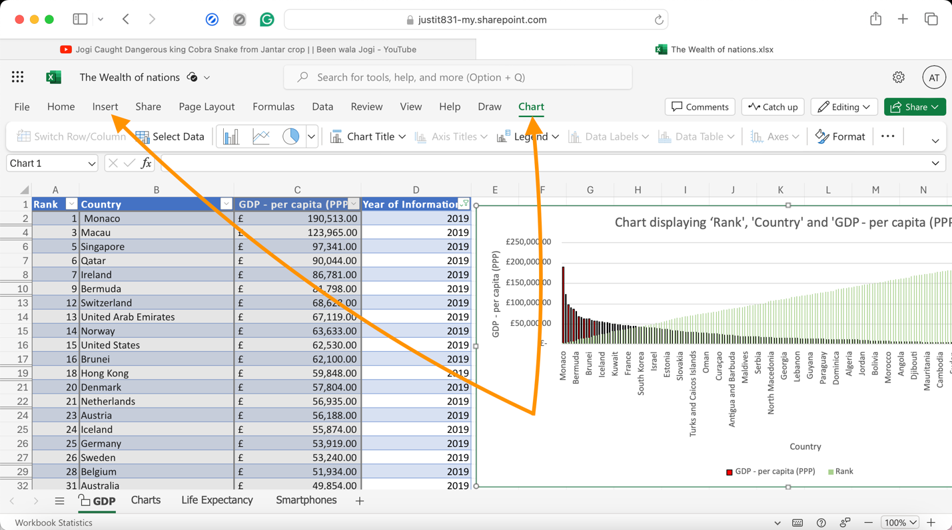

Then, a chart was created to display the following data: ‘Rank,’ ‘Country’ and ‘GDP - per capita (PPP). This was done by going to the Insert tab and then selecting the chart. Column chart was chosen for this data.

All three variables: Rank, Country, and GDP – per capita (PPP) were first drawn on the same graph. And after that, two separate graphs were plotted one showing Rank against each Country and another - GDP against each Country.

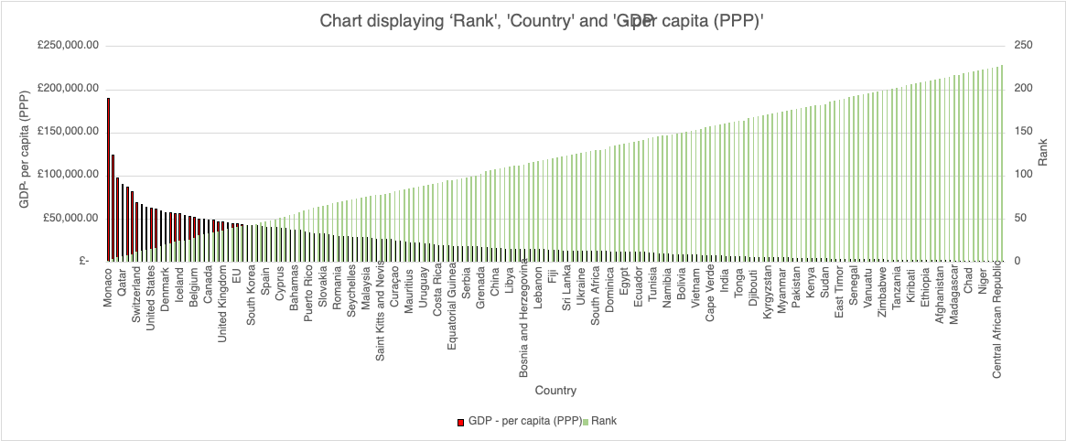

Since the assignment asks us to create a chart that displays three variables namely - ‘Rank,’ ‘GDR per Capita (PPP)’ and ‘Country,’ so a Clustered column chart was drawn to show ‘GDR per Capita (PPP)’ on the primary vertical axis and the ‘Ranks’ on the secondary vertical axis against each ‘country’ on the horizontal axis.

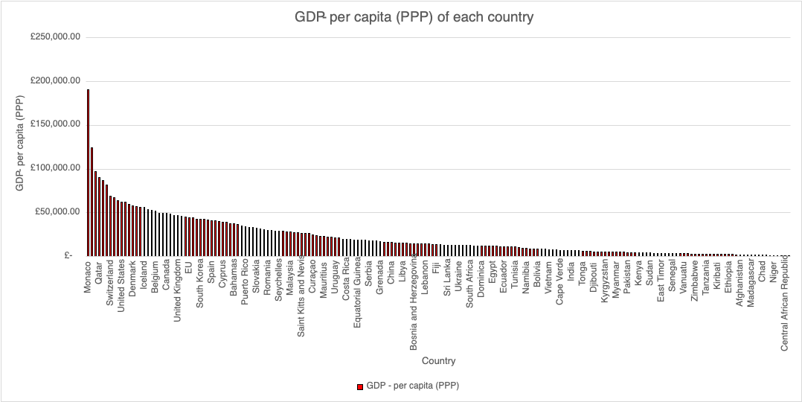

1. A clustered column chart showing the GDP – per capita (PPP) of each country.

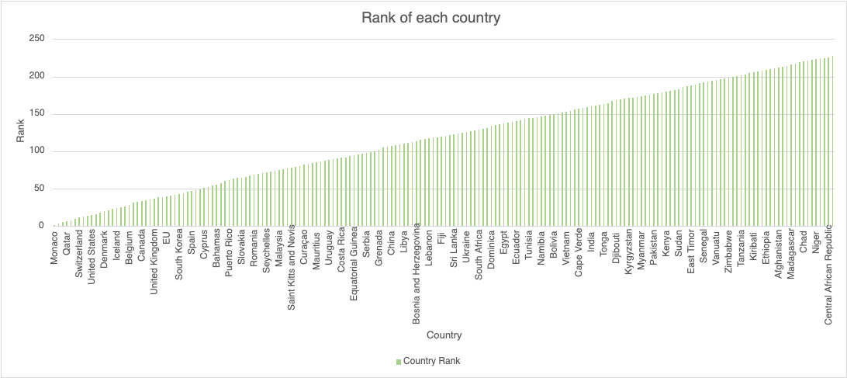

1. A clustered column chart showing the ranks of each country.

6. All charts were titled and labelled with x and y axis.

7. The three charts were then moved to a new work sheet and named it ‘Charts’.

8.

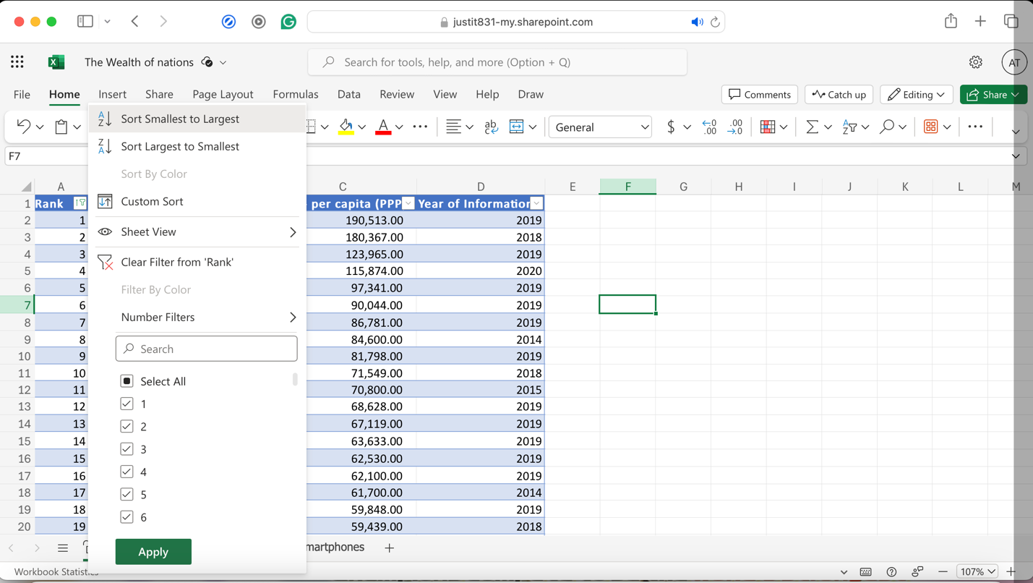

Here, the table was sorted to display the top 20 highest ranking countries on the screen.

9.

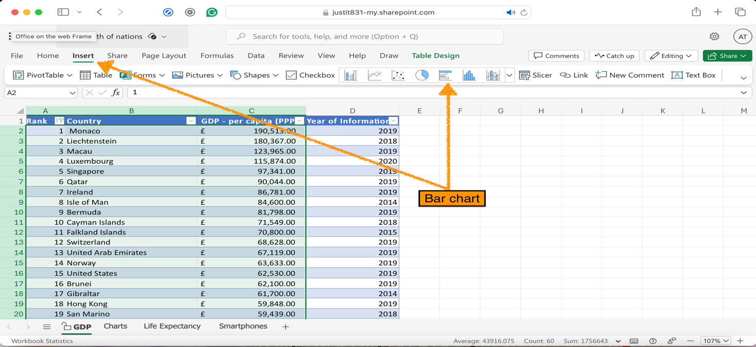

After highlighting the data, from the Insert tab – a bar chart was produced.

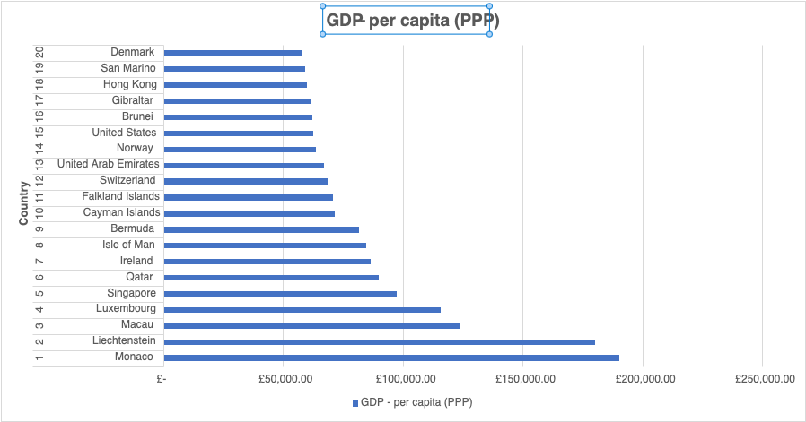A bar chart displaying the 20 highest ranking countries alongside their respective GDP – per capita (PPP).

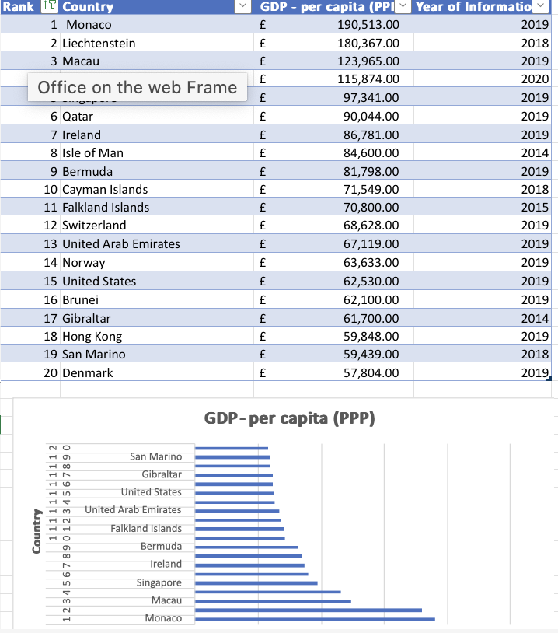

Here, the bar chart is shown as being placed underneath the table as per the assignment instruction.

10.

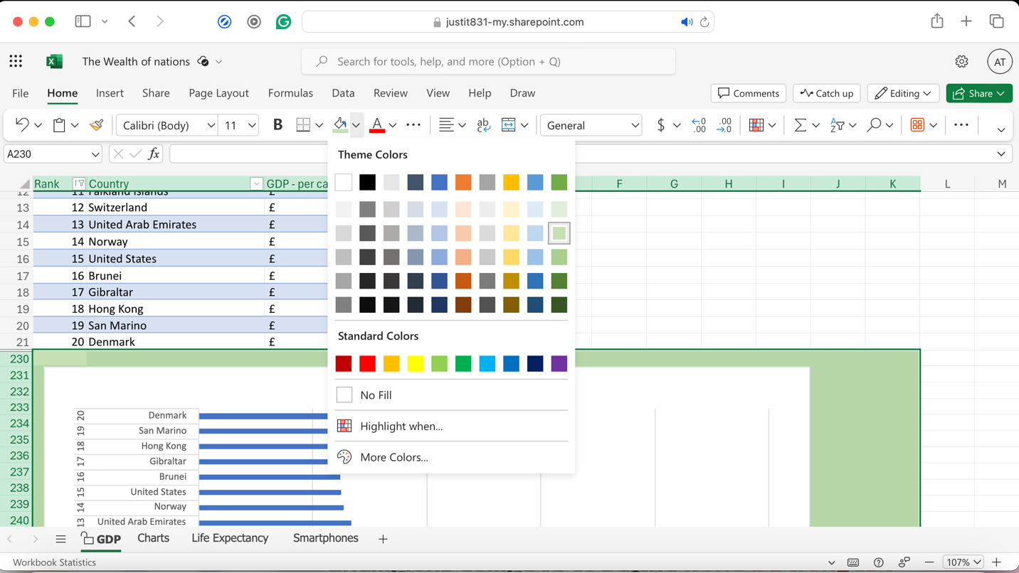

Highlighting the area below the table; behind the chart, the background was coloured using the fill colour option.

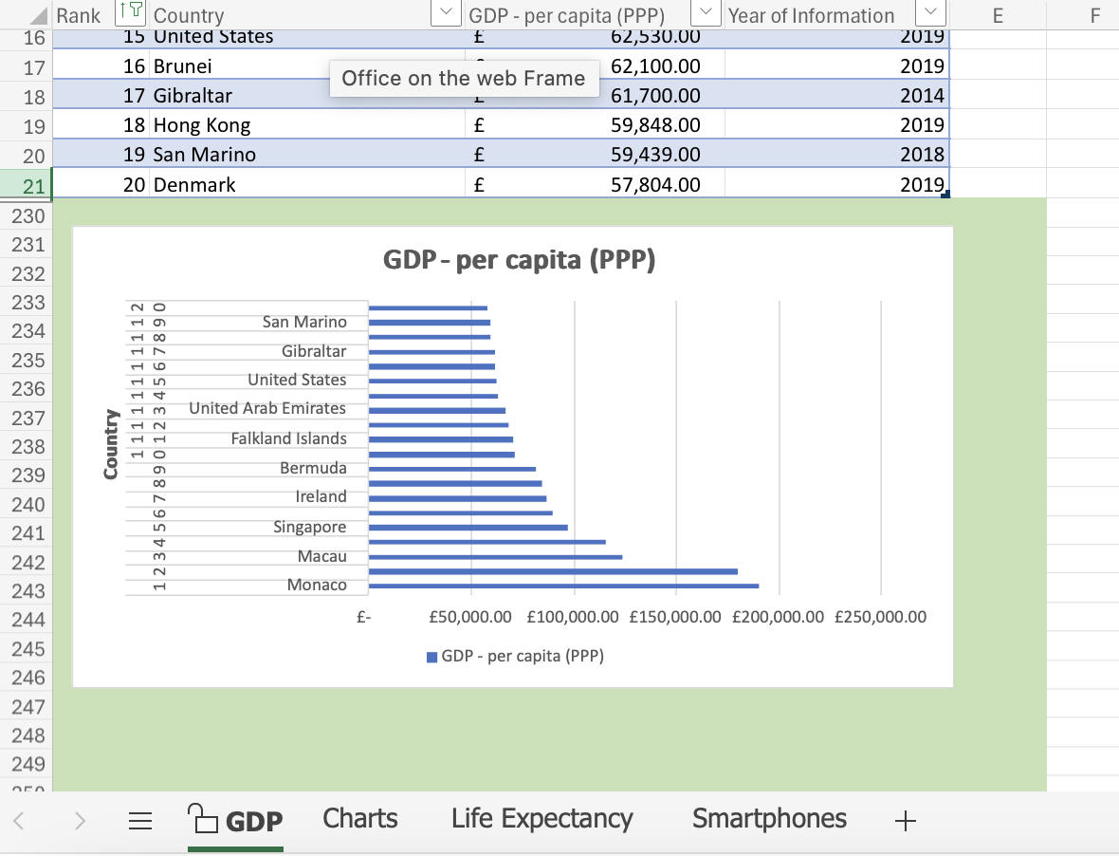

***Part – 3 (Creating Macros)***

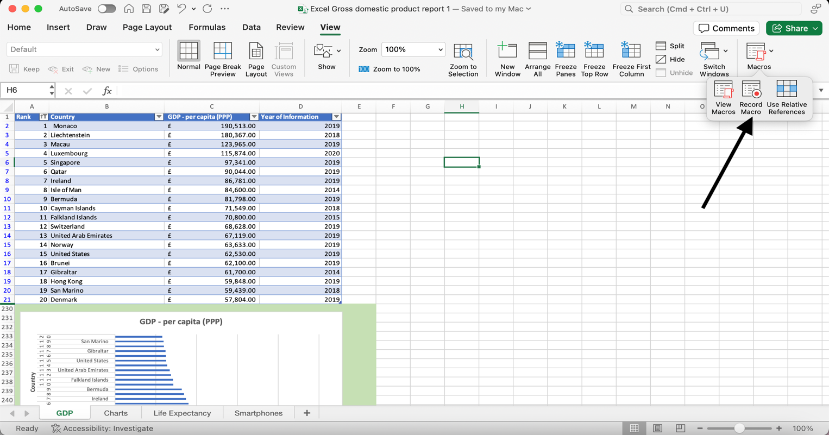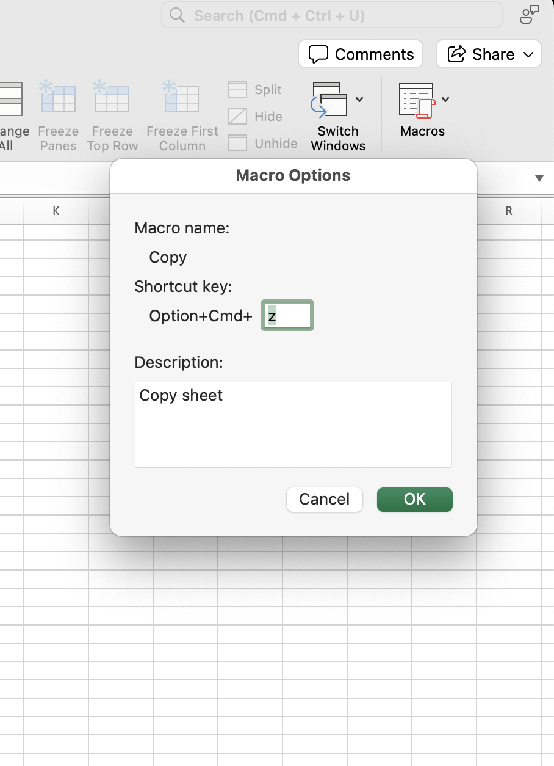Clicked on ‘Record Macro’ (This is available under the View tab).

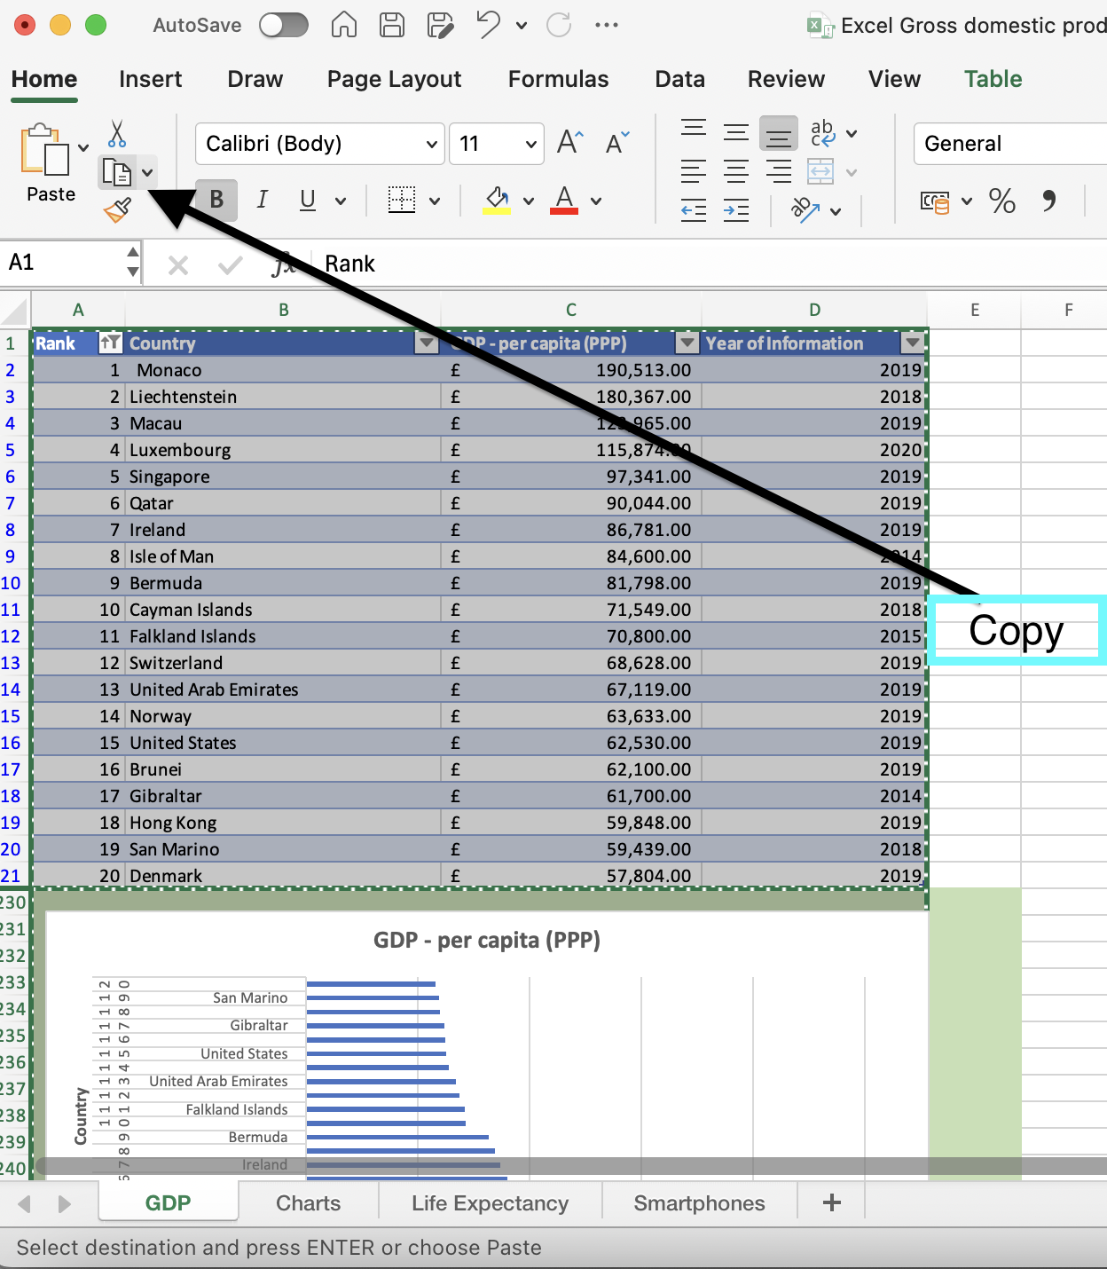

Then selected the area to copy. Clicked on the copy button or hit (Ctrl C).

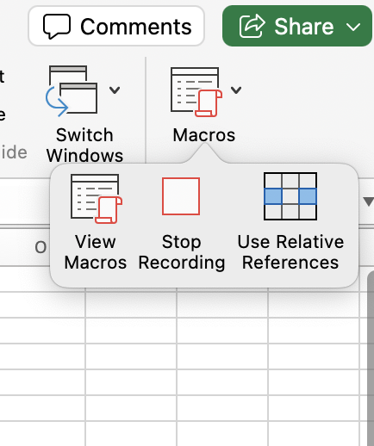 After that, stopped recording the macro.

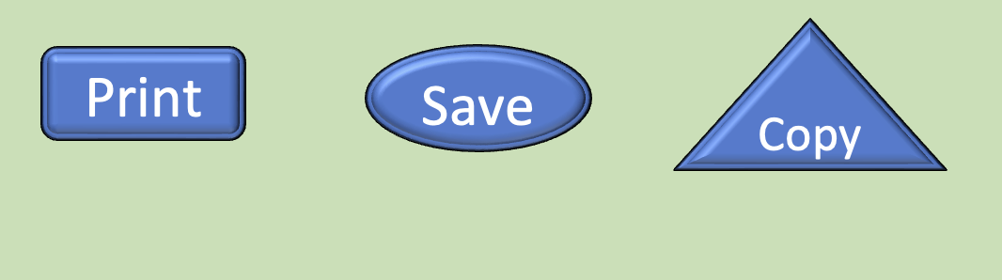

Made three shapes or buttons like in the picture above and assigned the copy macro to the copy button by right-clicking on it. Similarly, did the same for the other two buttons. For Print – used short cut (Ctrl p) and Save (Ctrl s). These can also be done from the File menu.

|  |  |  |  |
| --- | --- | --- | --- |
| **Rank** | **Country** | **GDP - per capita (PPP)** | **Year of Information** |
| 1 | Monaco | £ 190,513.00 | 2019 |
| 2 | Liechtenstein | £ 180,367.00 | 2018 |
| 3 | Macau | £ 123,965.00 | 2019 |
| 4 | Luxembourg | £ 115,874.00 | 2020 |
| 5 | Singapore | £ 97,341.00 | 2019 |
| 6 | Qatar | £ 90,044.00 | 2019 |
| 7 | Ireland | £ 86,781.00 | 2019 |
| 8 | Isle of Man | £ 84,600.00 | 2014 |
| 9 | Bermuda | £ 81,798.00 | 2019 |
| 10 | Cayman Islands | £ 71,549.00 | 2018 |
| 11 | Falkland Islands | £ 70,800.00 | 2015 |
| 12 | Switzerland | £ 68,628.00 | 2019 |
| 13 | United Arab Emirates | £ 67,119.00 | 2019 |
| 14 | Norway | £ 63,633.00 | 2019 |
| 15 | United States | £ 62,530.00 | 2019 |
| 16 | Brunei | £ 62,100.00 | 2019 |
| 17 | Gibraltar | £ 61,700.00 | 2014 |
| 18 | Hong Kong | £ 59,848.00 | 2019 |
| 19 | San Marino | £ 59,439.00 | 2018 |
| 20 | Denmark | £ 57,804.00 | 2019 |
| |  | | --- | |  | |  |  |  |
|  |  |  |  |
|  |  |  |  |
|  |  |  |  |
|  |  |  |  |
|  |  |  |  |
|  |  |  |  |
|  |  |  |  |
|  |  |  |  |
|  |  |  |  |
|  |  |  |  |
|  |  |  |  |
|  |  |  |  |
|  |  |  |  |
|  |  |  |  |
|  |  |  |  |
|  |  |  |  |
| Copy  y  Print  Save   |  | | --- | |  | |  |  |  |
|  |  |  |  |
|  |  |  |  |
|  |  |  |  |
|  |  |  |  |
|  |  |  |  |
|  |  |  |  |

By clicking on the above ‘Copy’ macro button, the highlighted area was copied from the original excel document and then pasted in this word document.

**Inserting header and footer in the excel file**.

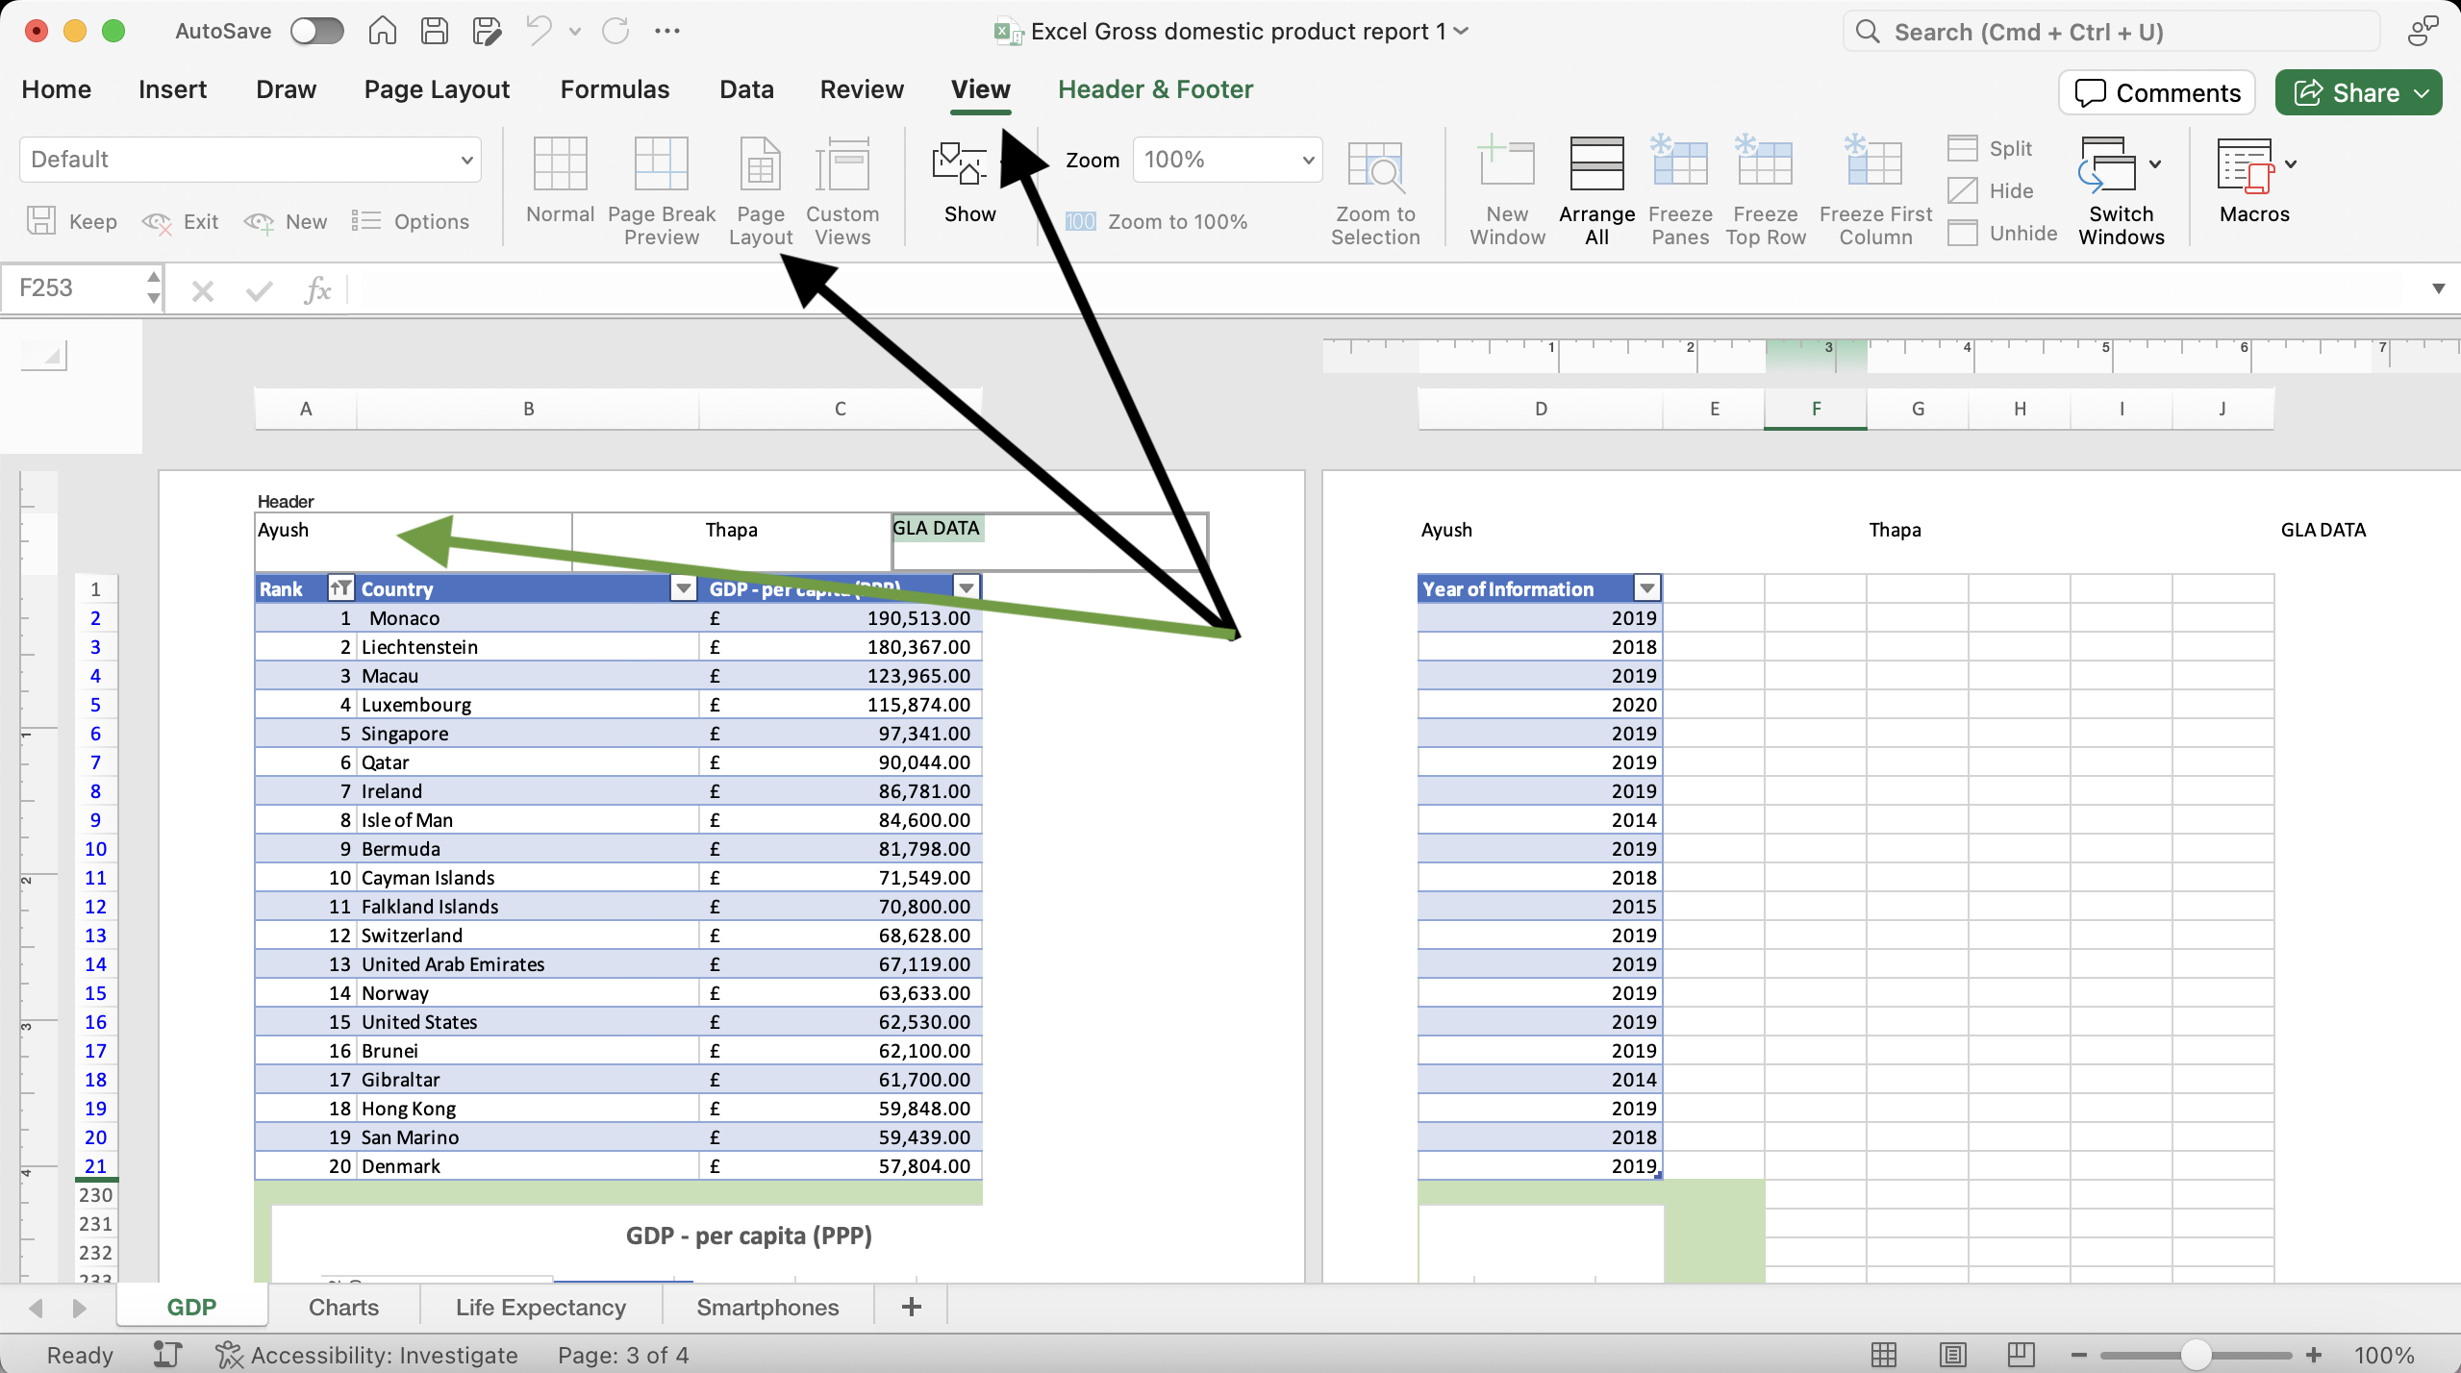

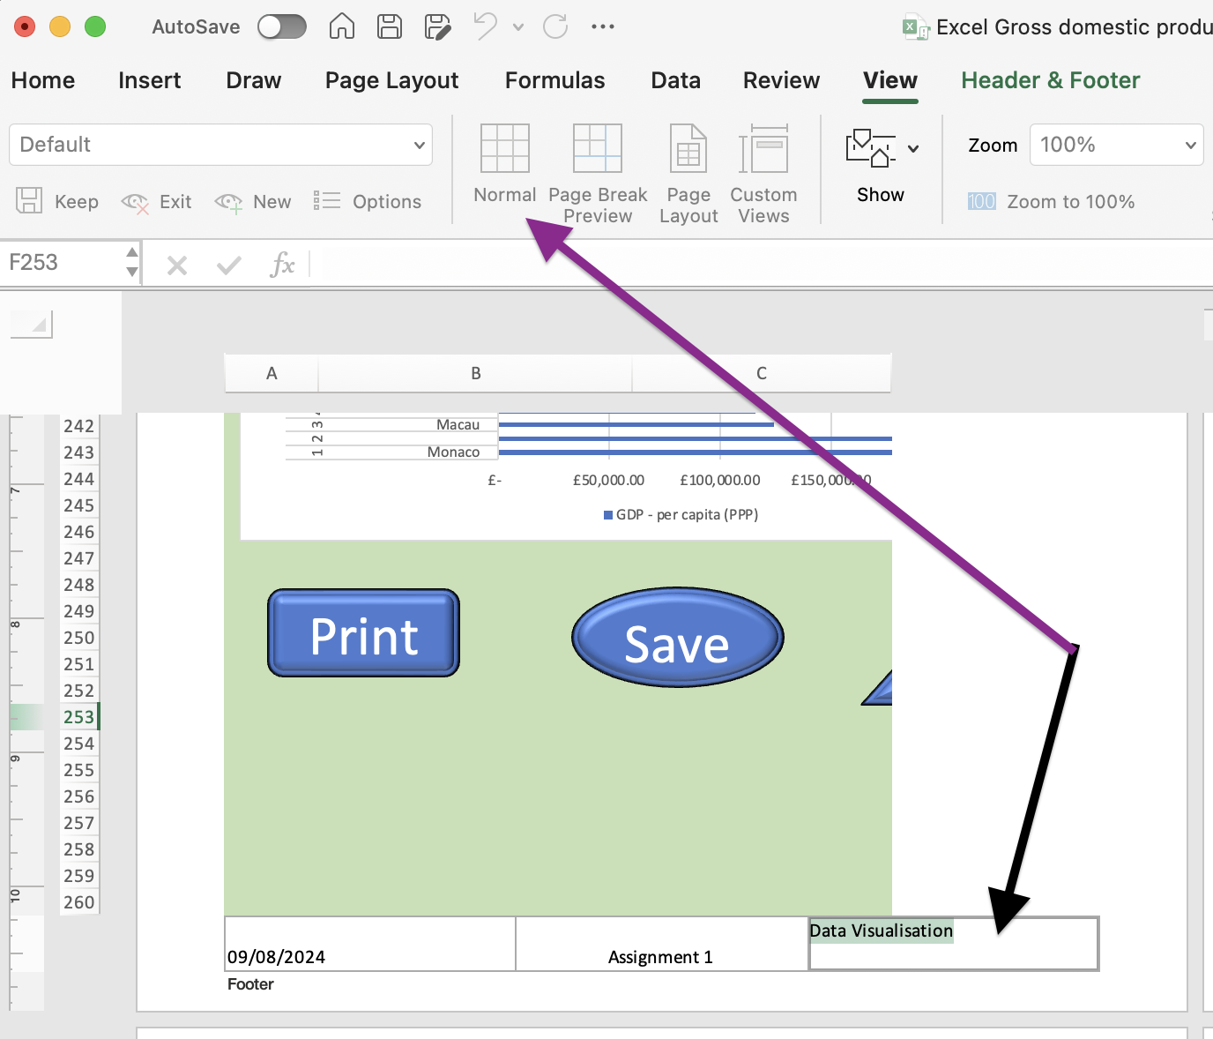

In the Excel file, went to View tab > Page Layout. That way Header & Footer were added in the excel file. Once done, simply clicked on the Normal view on the left side of ‘Page Layout’ to exit.

# Third Task

## Tableau

1. **Importing excel data into Tableau:**

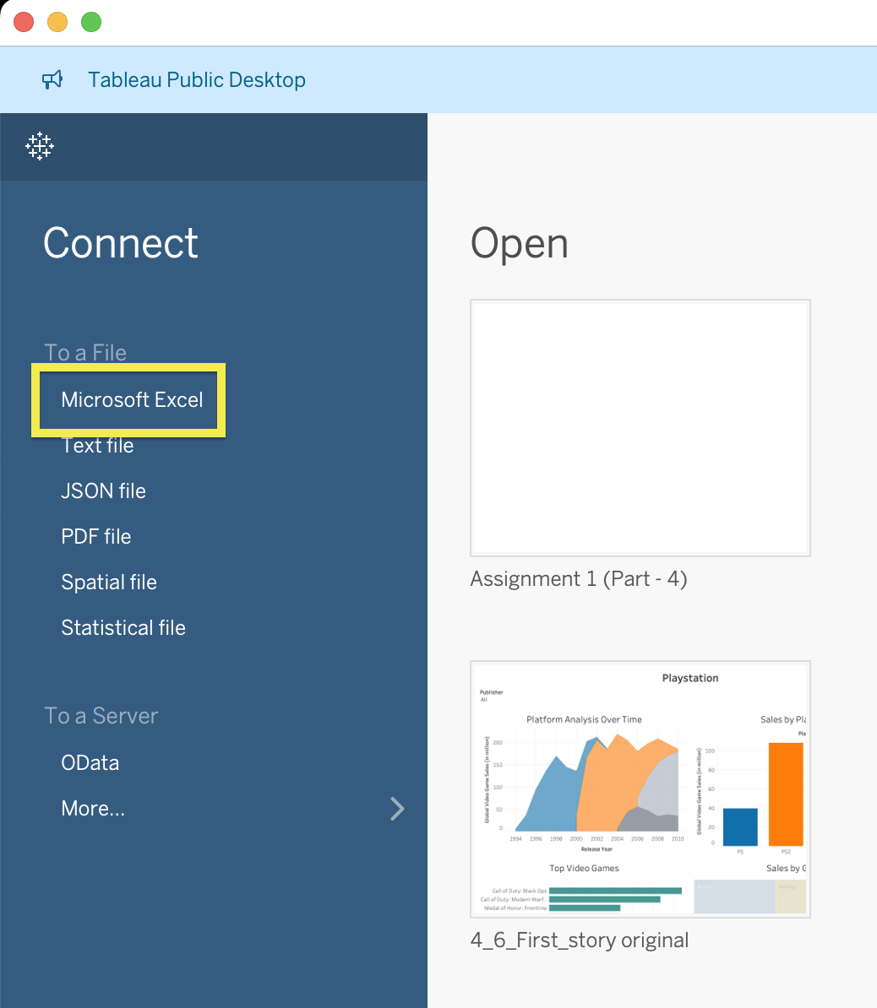

Opened Tableau, connected to Microsoft Excel file. Selected – ‘The Wealth of nations’ excel file.

1. **Setting relationships:**

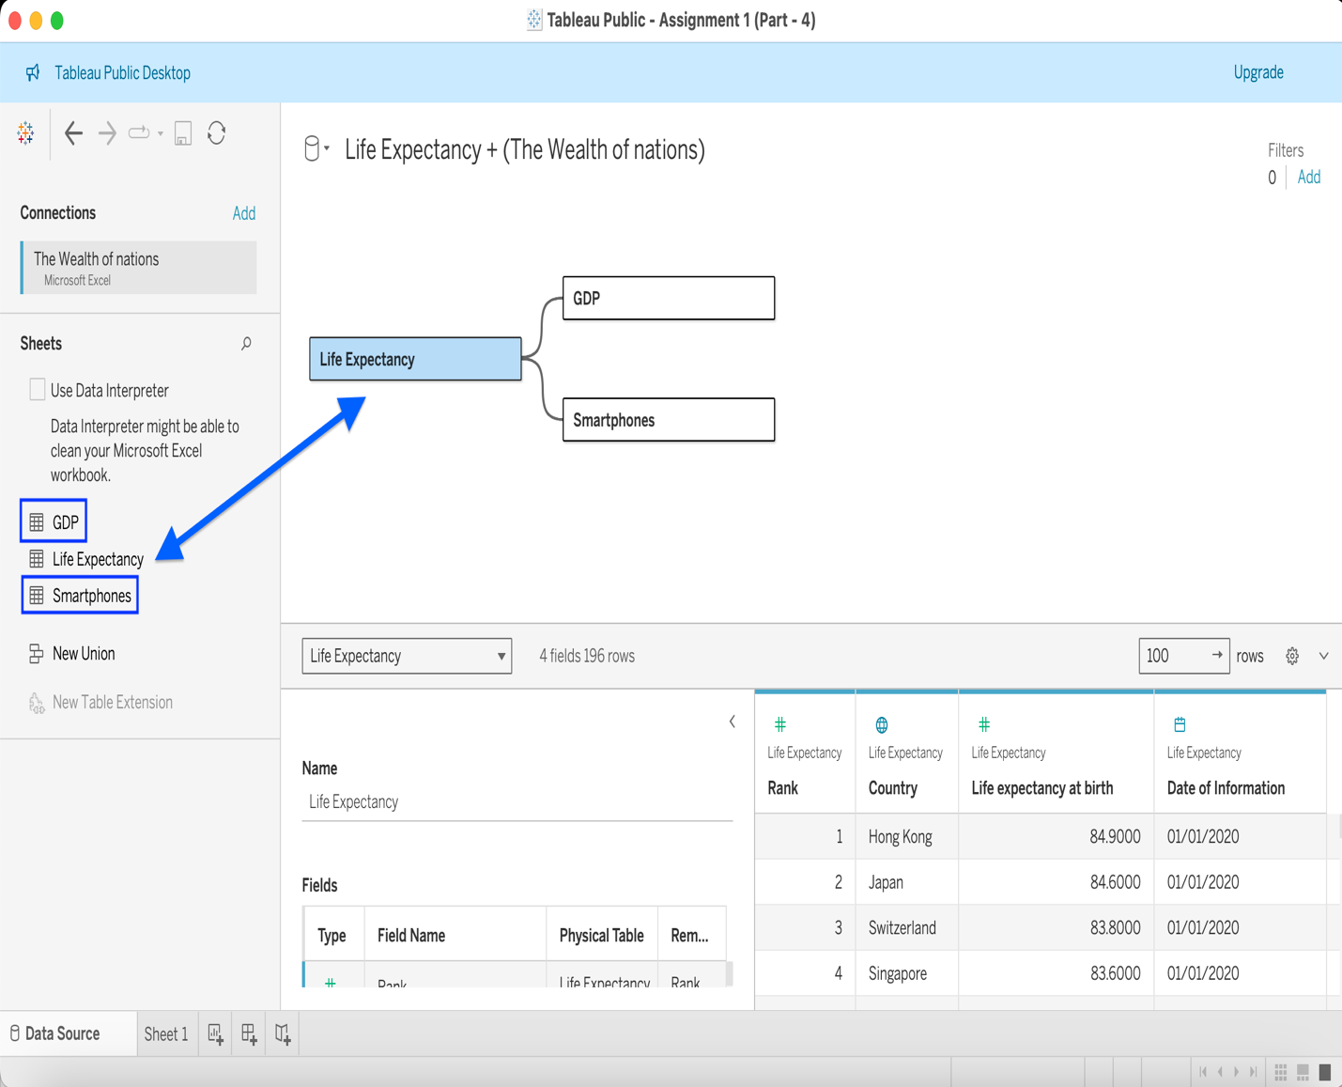

Then arranged the relationships. Either double click or, drag and drop ‘Life Expectancy’ from the left panel to the right empty space. Then dragged ‘GDP’ the same way connecting it to ‘Life Expectancy.’

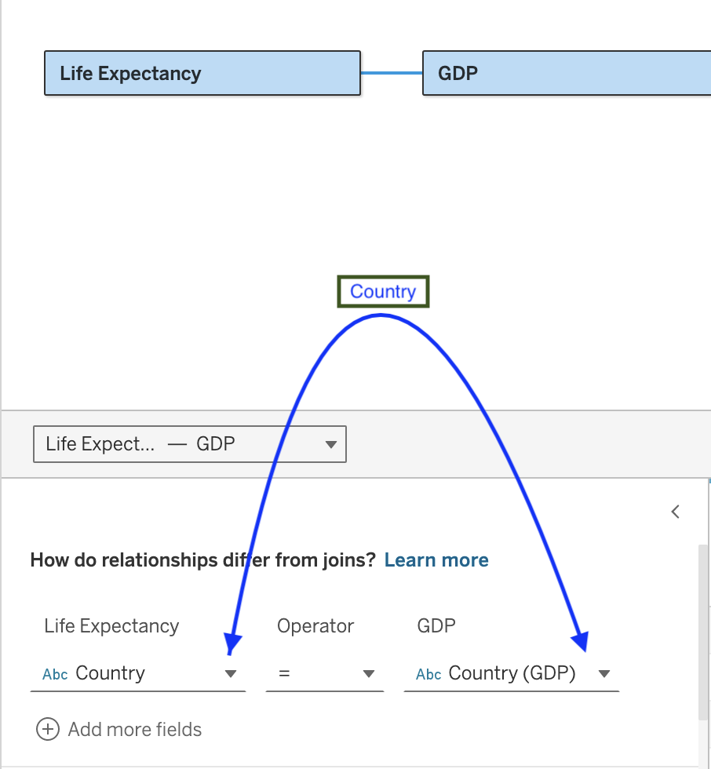Since, Country is the common column in all fields/ sheets, so chose ‘Country’ from the drop down on both fields as shown above. Validated the same relationship between ‘Life Expectancy’ and ‘Smartphones’, too. Here, the visual arrangement of the sheets doesn’t matter, only the relationship between the columns matter. And that way, the inter-relationships were made valid.

1. **Checking data types:**

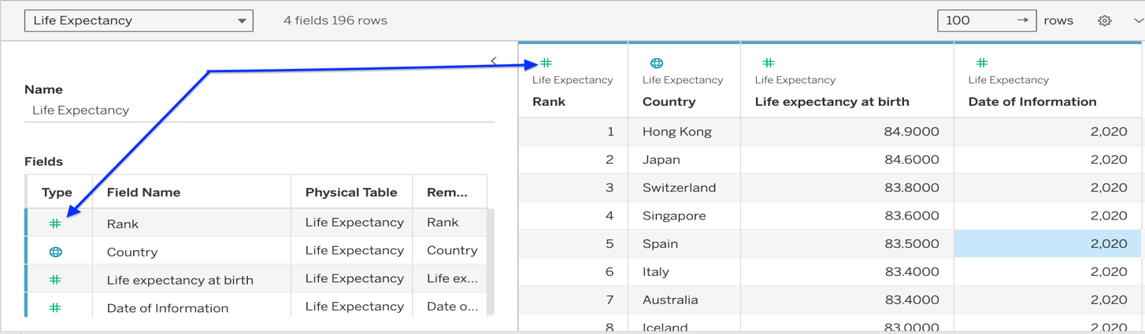

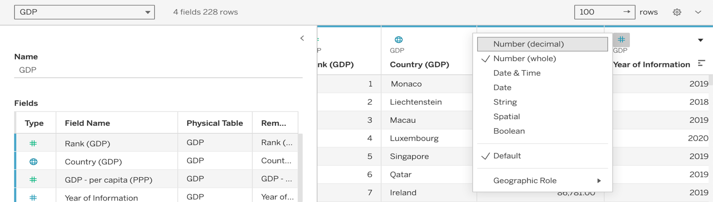

After that, checked the data types of all columns by clicking on the small data type icon as shown in the above picture (Either one is fine; both are same). It has been mentioned in the instruction PDF that the year of information column can be a whole number. All columns appeared to have the correct data types by default.

1. **Building charts:**

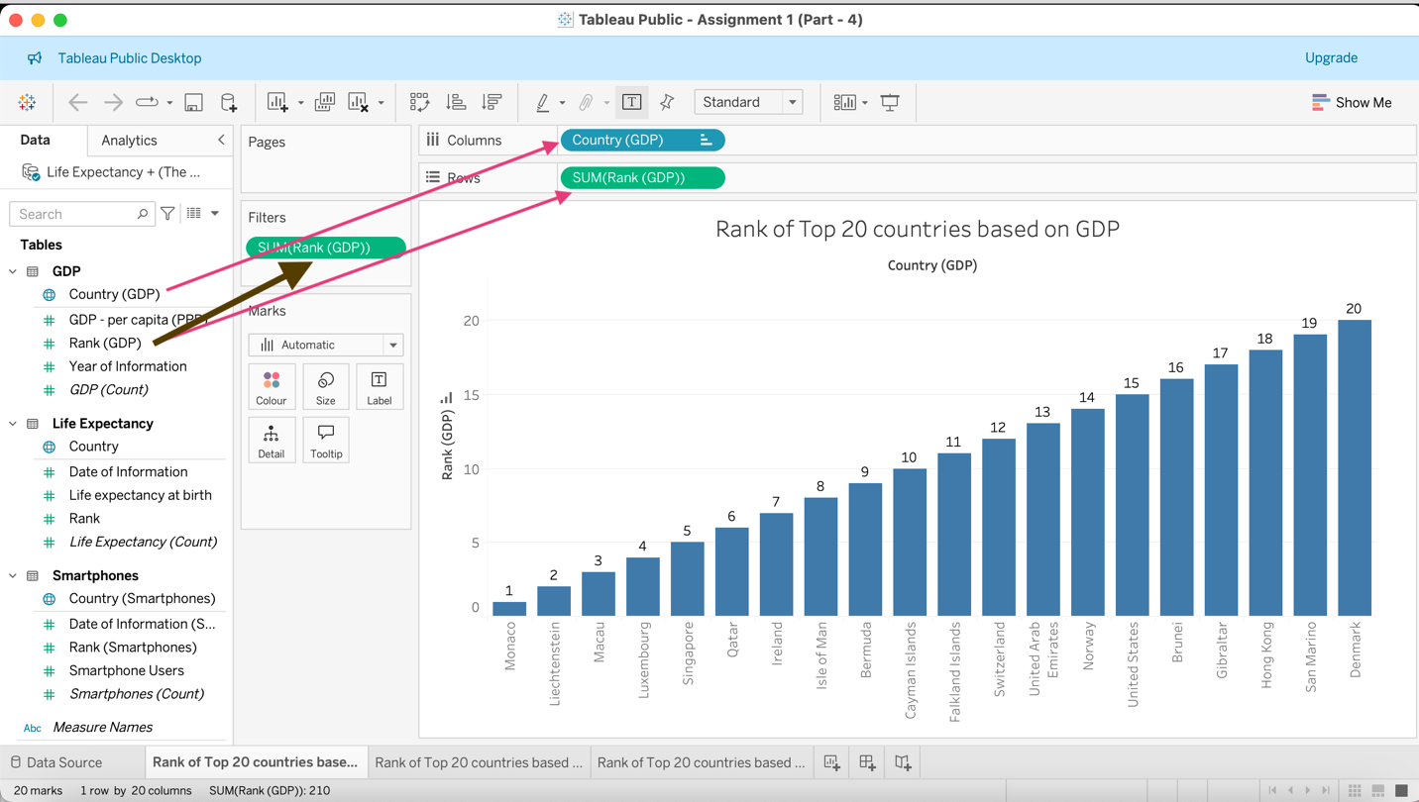

To draw a chart representing the rank of top of 20 countries based on GDP (Rank Vs Country graph), double-clicked or dragged “Rank (GDP)” from the side bar to the Rows and “Country (GDP)” to the Columns shelves. Dragged and dropped “Rank (GDP)” to the Filters card and then from the “At most” field, typed in “20” to filter out the top 20 countries only. Left the “Include Null Values” checkbox empty as it was (Picture below).

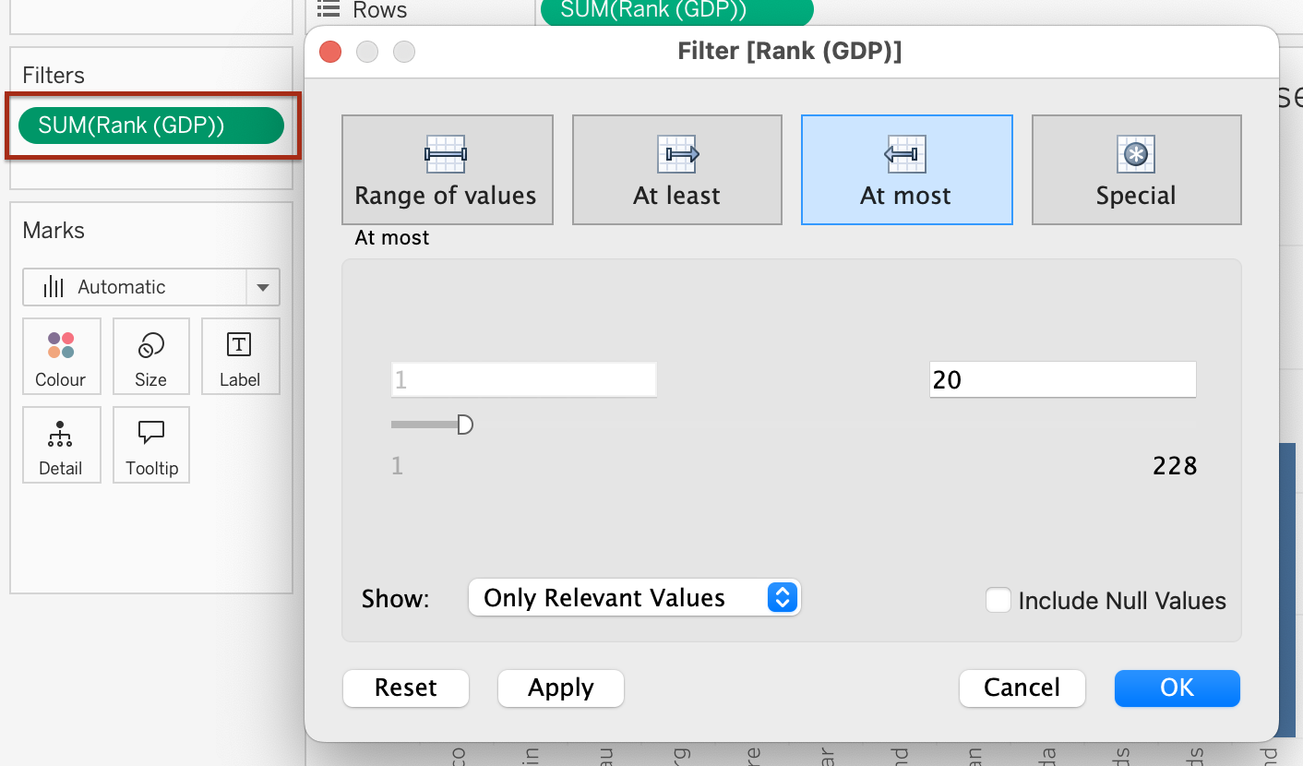

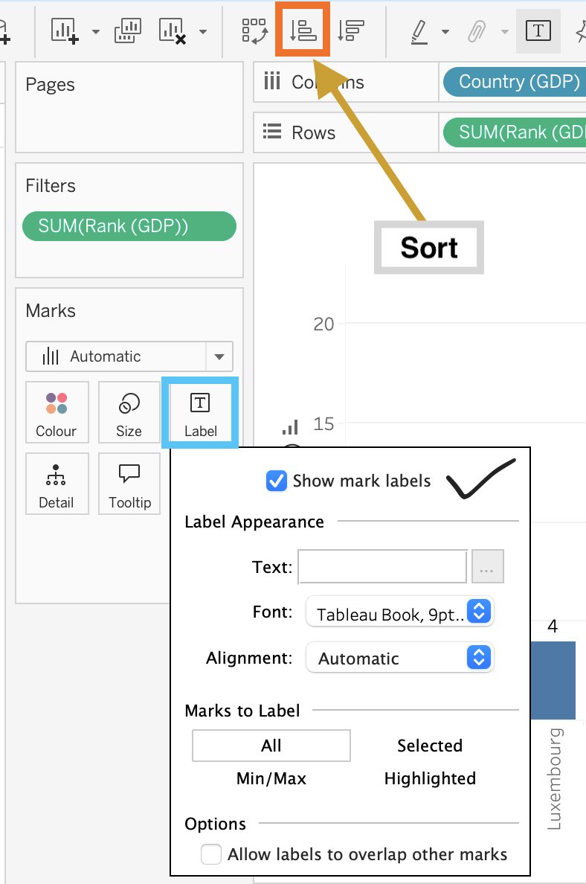

Sorted the graph in ascending order by clicking on the icon shown above in the toolbar picture. To show the ranks as data levels in the column chart, clicked on “Label” and then selected “Show mark labels”. The charts were then coloured by clicking on the “Colour” icon within the “Marks” field on the left in the above picture. Repeated the same process for “life Expectancy” and “Smartphones” tables to draw the other two column charts as screenshots below.

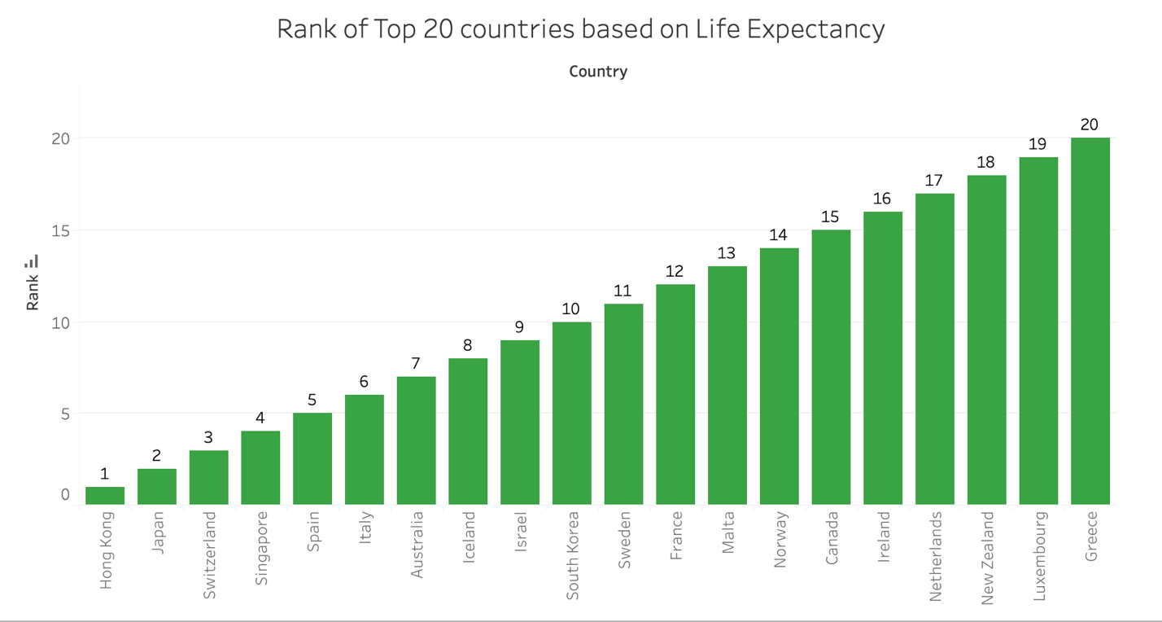

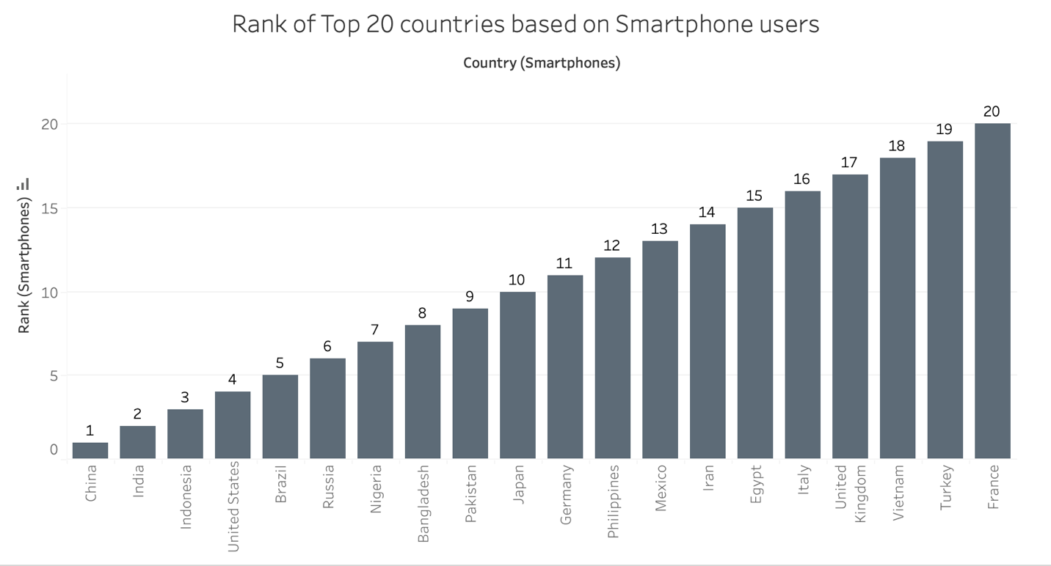

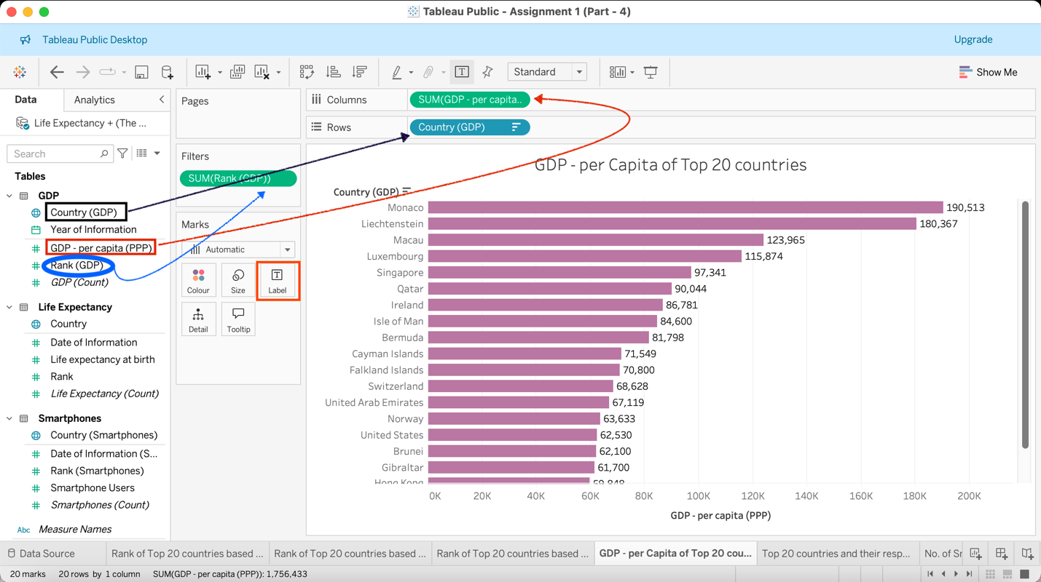

Next up was a bar chart showcasing the GDP – per Capita of the top 20 highest ranking countries. From the side bar on the left-hand side, under ‘Tables’, dragged and dropped the ‘Country (GDP)’ onto the ‘Rows’ shelf, and ‘GDP –per capita (PPP)’ onto the ‘Columns’ shelf. Then filter the top 20 ranks by moving ‘Rank (GDP) onto the ‘Filters’ card. To do this - either select ‘Ranges of values’ from 1 to 20 or, select ‘At Most’ 20. Both do the same thing. Then to display the GDP values on the chart, simply clicked the ‘Label’ Marks card and selected ‘Show mark labels.’

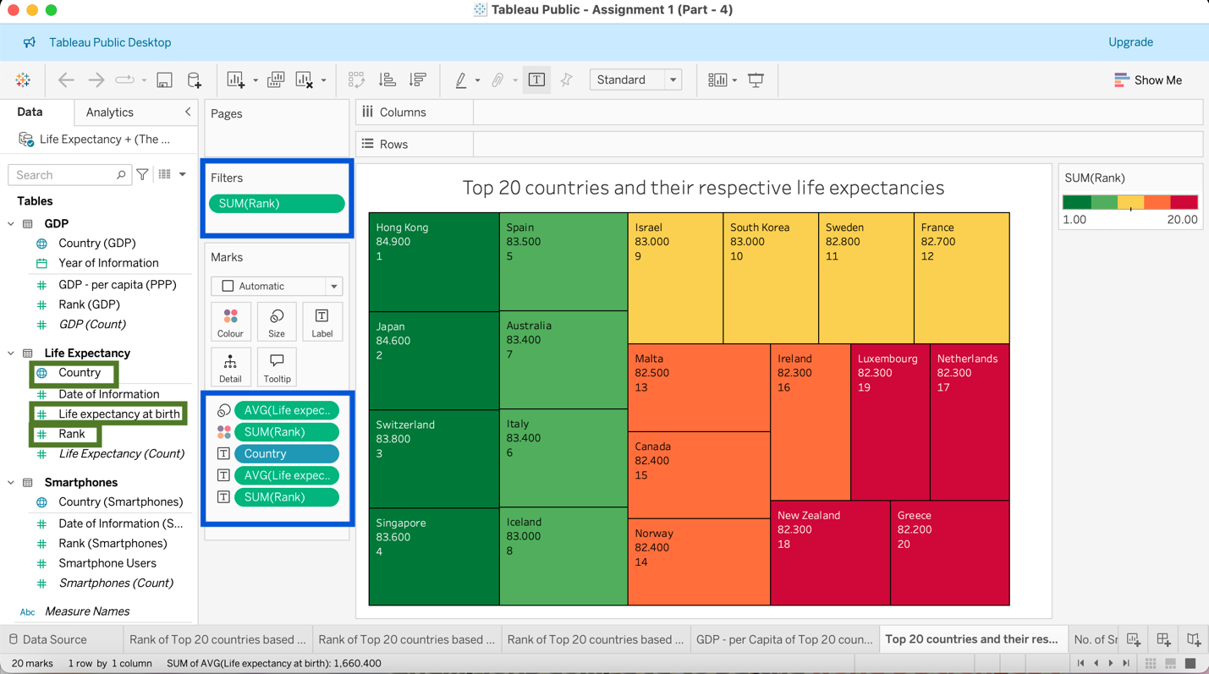

The fifth chart was a treemap. The fields from ‘Life Expectancy’ table in the side bar were dragged and dropped onto the ‘Filters’ and ‘Marks’ cards as shown above. The measure for ‘Life expectancy at birth’ was selected as average and for the ‘Rank’, sum was selected. In fact, it doesn’t matter which aggregation is selected in this context, both Sum and Average give the same result as there is only one unique value for each country. Filter was applied to show only the top 20 highest ranking countries (where, 1 is the highest rank and 20 is the lowest).

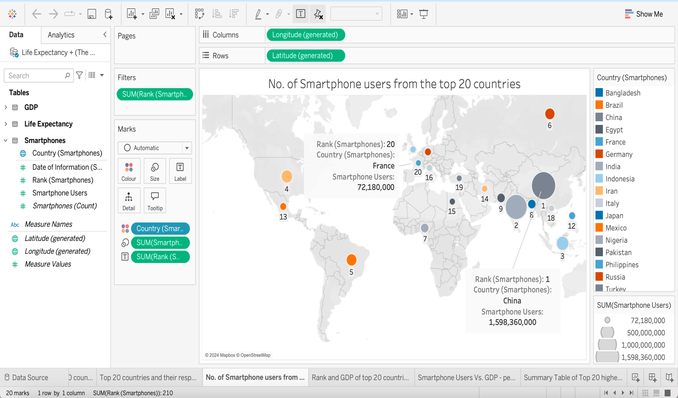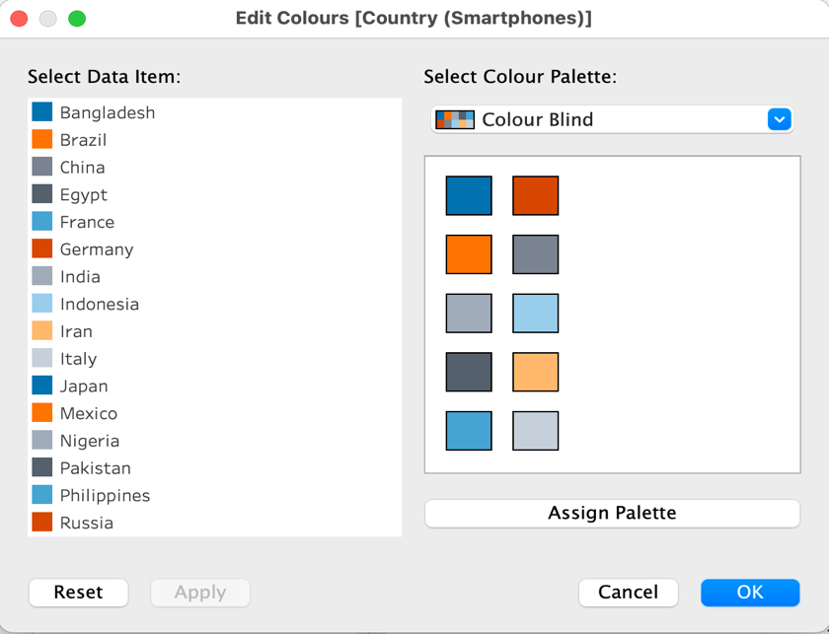

Sixth visual was a symbol map. In here, the colour of the circles shows which country it is, and its size shows how big is the number of smartphone users for that country. ‘Colour Blind’ option was chosen from the colour palette to make it colourblind-friendly. The country that had the highest number of smartphone users was China, whilst France ranked the lowest in the top 20 list. Those two points were annotated by right-clicking and selecting the ‘Annotate’ option.

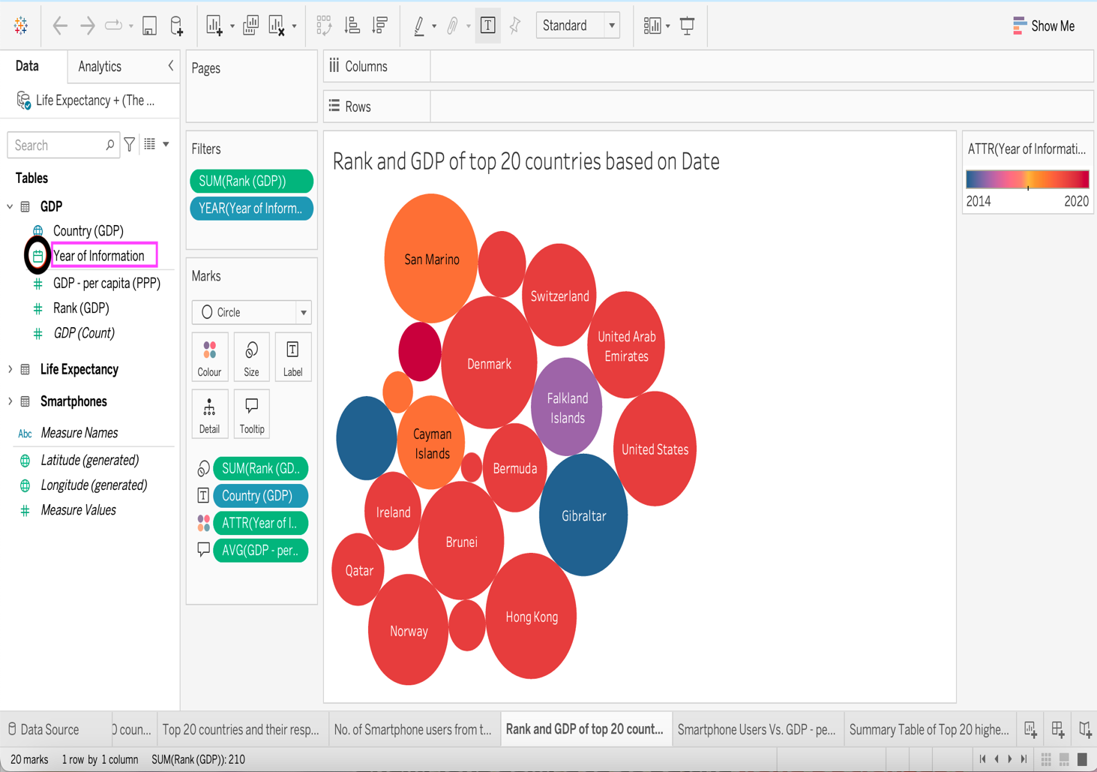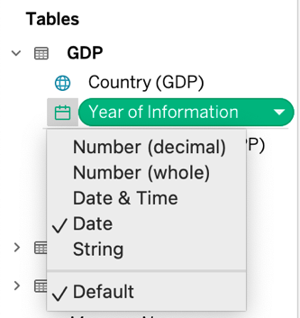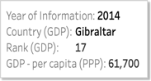

The above chart is packed bubbles. Here the colours of the bubbles show the years of information. Dark Red is 2020, Reds are 2019, Oranges are 2018, Violet is 2015 and the blues are 2014. During this making of this visualisation, the data type of ‘Year of Information’ was changed from the default – ‘Number (Whole)’ to ‘Date’ (as shown in the above picture), so that the years could be filtered, and the tooltip would display years as dates.

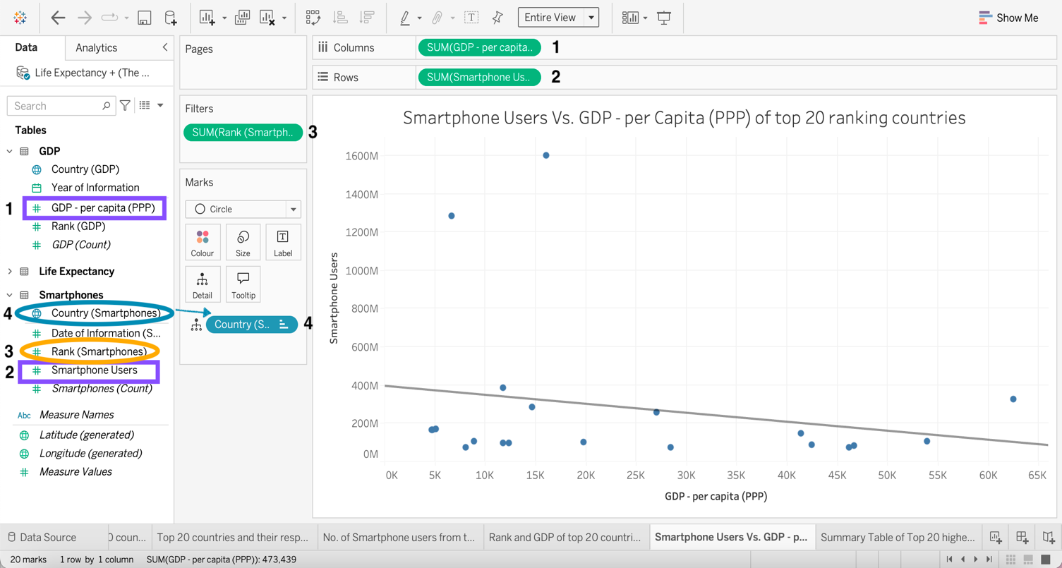

A scatter plot of Smartphone Users against GDP – per capita (PPP) for the top 20 highest ranking countries.

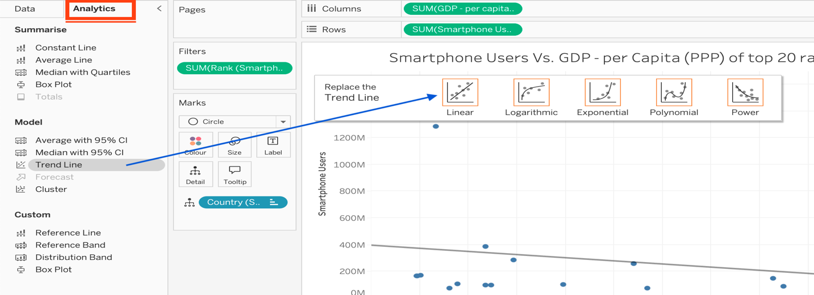

From under the ‘Analytics’ side bar, a trend line was drawn by dragging and dropping ‘Trend Line’ on the first option – ‘Linear’.

It appears that in general, as the GDP – per capita increased, the number of smartphone users decreased.

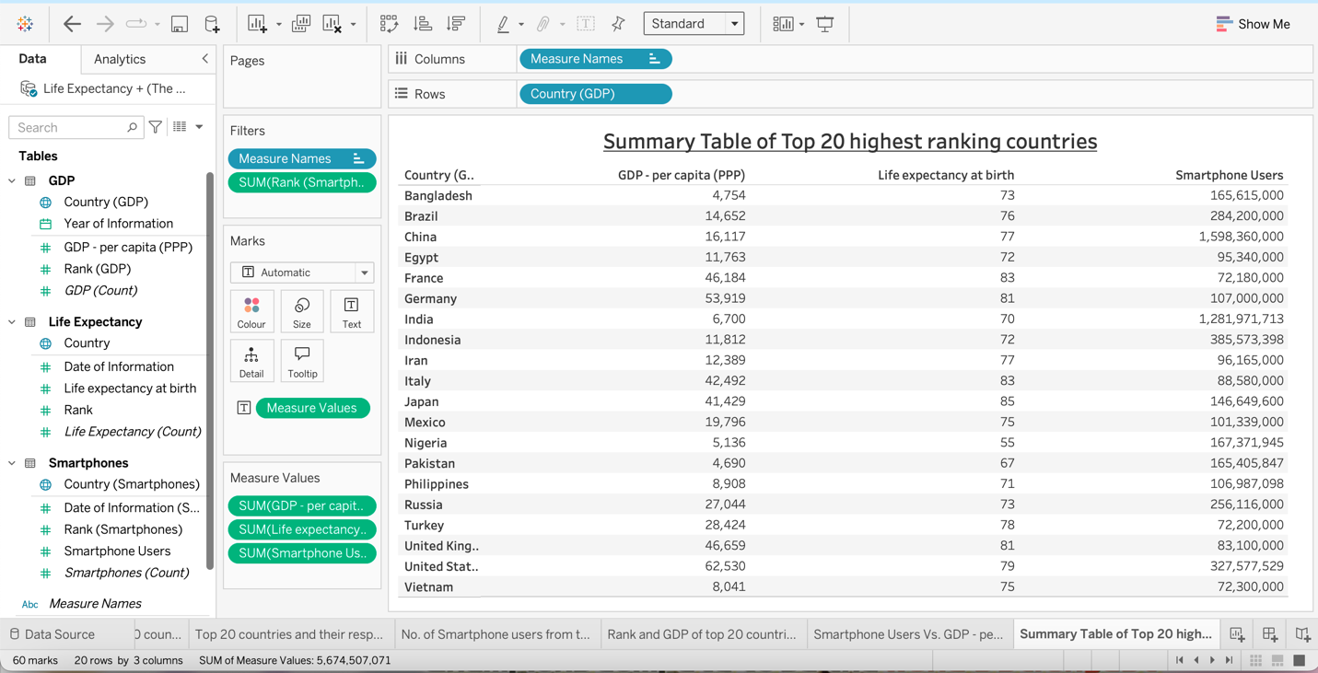

And finally, the ninth visualisation - a text table was created featuring the top 20 highest Smartphone user countries, GDP and Life expectancy. The names were sorted in alphabetical order.

**Building dashboards**:

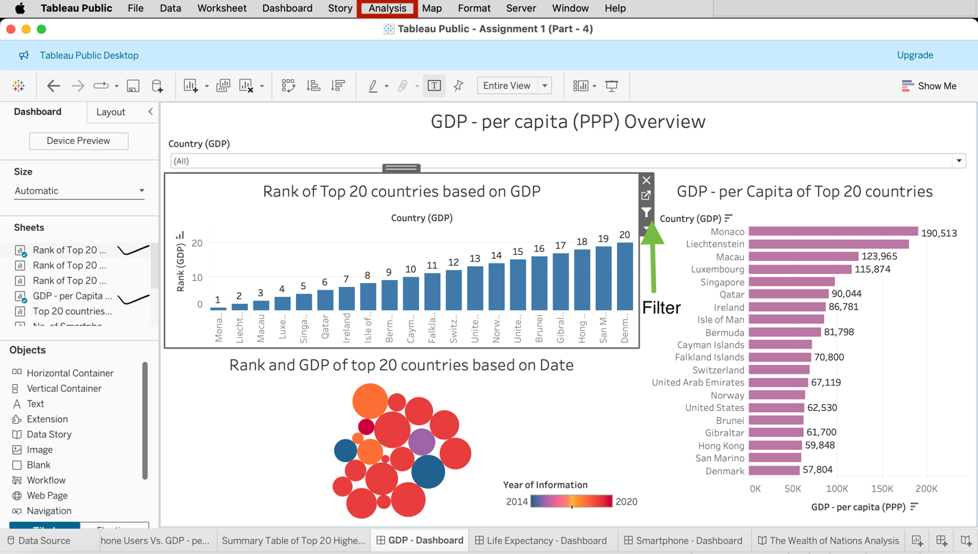

*Creating a dashboard called ‘GDP – per capita (PPP) Overview*: Either double click or drag and drop the three GDP related worksheets from the side bar onto the empty canvas as shown in the above screenshot. ‘Year of Information’ legend was made floating and was shifted beside the packed bubbles chart. The dashboard title was added. ‘Country (GDP)’ filter was added underneath the title by clicking on the packed bubbles chart and then clicking on ‘Analysis’ in the toolbar. After that, navigated to "Filters" in the dropdown menu and selected Country (GDP). Then, changed the filter style to "Single Value (dropdown)" and dragged it below the title. Following that, the filter option was enabled in the top left hand side column chart.

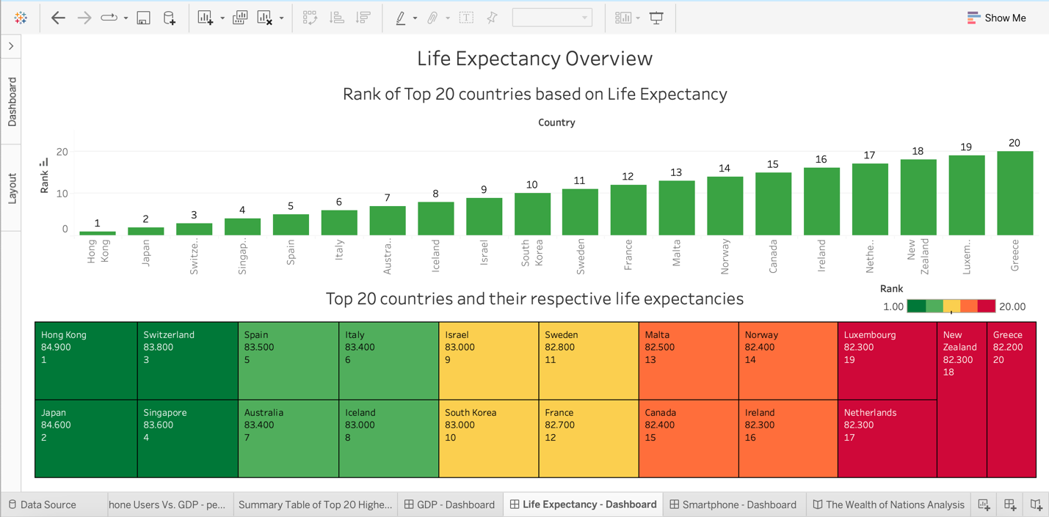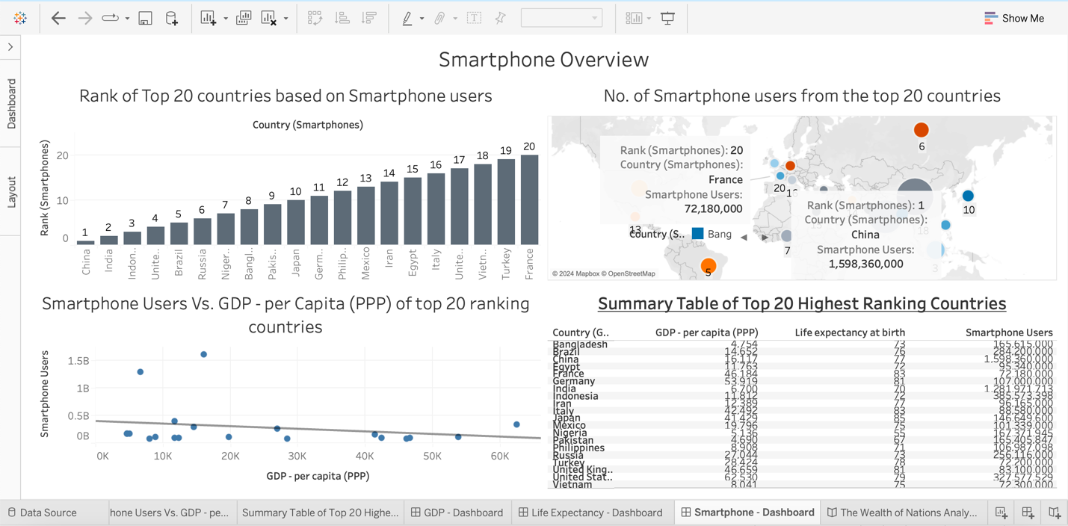

Similarly, created two other dashboards called ‘Life Expectancy Overview’ with the filter option enabled in the treemap and ‘Smartphone Overview’ with the filter option enabled in the Column chart.

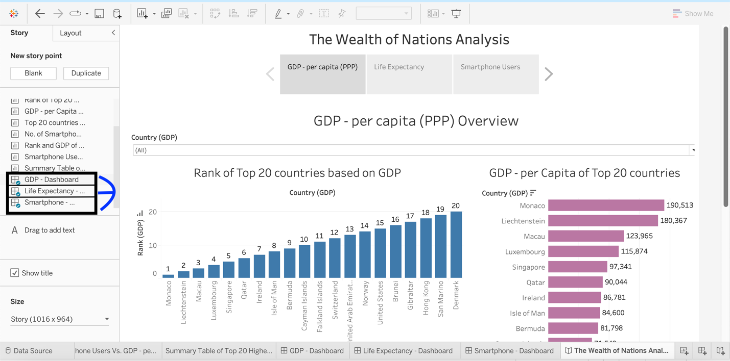

At last, all three dashboards were put together from the side bar on the left to form a story named – ‘The Wealth of Nations Analysis.’ The story’s title was centred. The captions were renamed as ‘GDP – per capita (PPP), ‘Life Expectancy’ and ‘Smartphone Users.’

# A reflective

At the beginning of the project, I was using the online web version of MS Excel and MS Word, so the online features were limited. For instance: on Microsoft Excel web version, ‘Macro’ tool is not available; for Microsoft Word web version, ‘Cover Page’ feature is not available. So, to fix these kinds of problems, I used a one-month trial version of Office 365. Using this trial license enabled me to access the desktop version of MS Excel and MS Word and utilise their full features, and that included the macro and cover page issues. This way I was able to resolve the problems.

With regards to Tableau, most of the parts went smoothly. Wherever and whenever, I struggled, I went back and revised my class/ lesson notes. Besides this, I experimented and explored different things within the tableau interface. This helped me learn more about the tableau and visualisation per se. Eventually, I overcame any difficulties and finished all the tasks.

So, to conclude, all went well for this assignment at the end of the day. And for that reason, I feel happy, motivated and satisfied with a feeling that I have learnt new knowledge and skill that I didn’t have before.

## Reference

* What is a data governance policy? examples + templates (no date) Segment. Available at: https://segment.com/data-hub/data-governance/policy/ (Accessed: 01 August 2024).